Design document and notes

Stages:

**Instrumentation Amplifier**

**60 Hz Notch Filter**

**7Hz High Pass Filter**

**31 Hz Low Pass Filter**

**1Hz High Pass Filter and Gain of 83 -455**

- gains are needed so that the voltage doesn’t fluctuate over 1 V

- making gains too small may increase the error incurred from digitally reading the data

**60Hz Notch Filter**

**Electrodes and placement**

- fp2 and o2, left mastoid

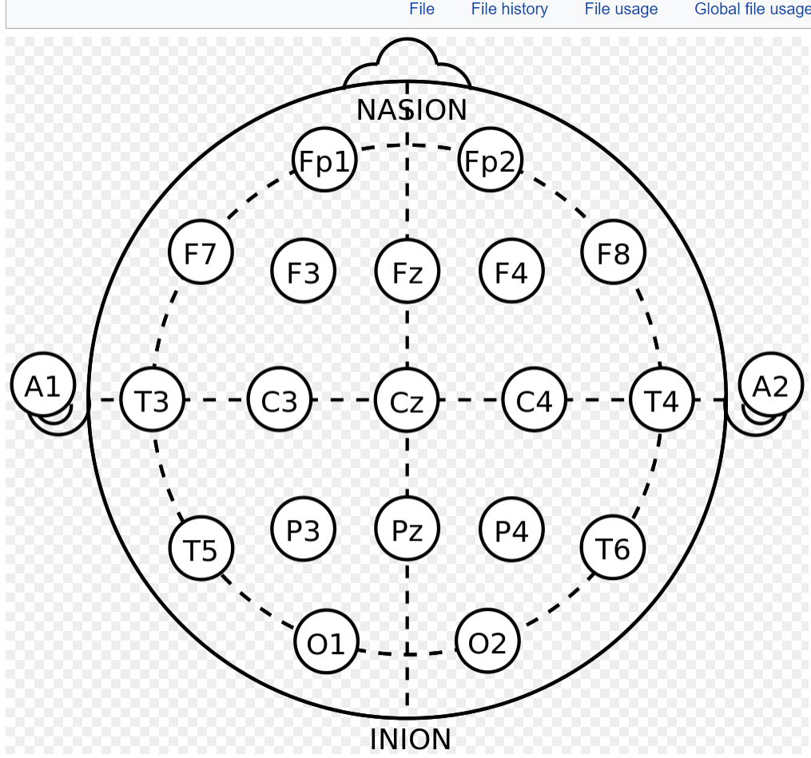

**FFT and classifier to determine if concentrated or relaxed**